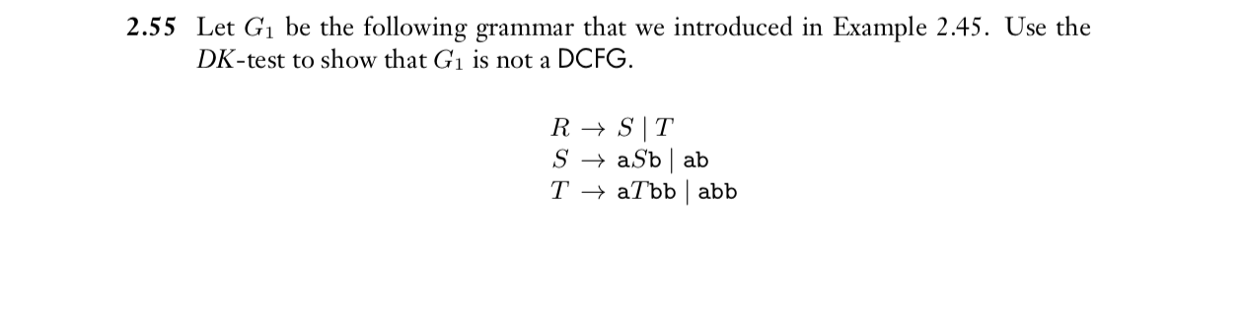

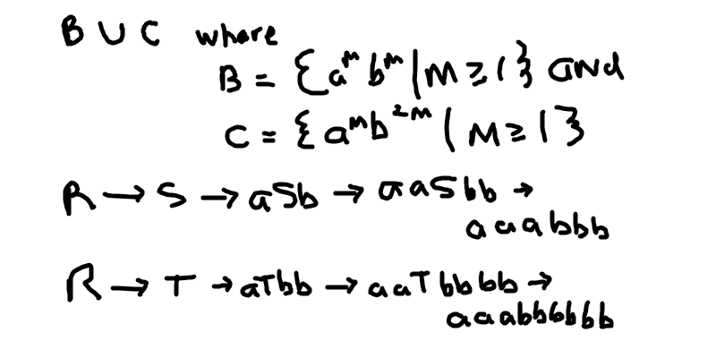

aaabbb & aaabbbbbb are unequal!

Thus this violates DK-test, so “G₁is not a DCFG”

